Parent Teacher meeting
Organised by IQAC ,Women’s College,Rayagada
Session 2022-23

A Parent teacher meeting was held on Dt.02-05-2023 at 10 am in the Girls common room of Women’s college, Rayagada. It was organized by IQAC of the college. Around 35 parents have attended the meeting. Principal Dr. Archana Patnaik Madam has Chaired the meeting. There was a good interaction between the parents and teachers. Teachers gave many information about activities of college. The parents are advised to encourage their daughters to participate in all programs of the college. The parents also appreciated the development of the college. They are very much glad about the teaching Process of the college. IQAC Coordinator Smt.Shantilata Mishro gave vote of thanks at last. About all teachers and 35 parents had attended the meeting.It was a successful one. Principal Dr.Archana Patnaik gladly appreciated the success of the meeting.

Some glimpses of the Meeting
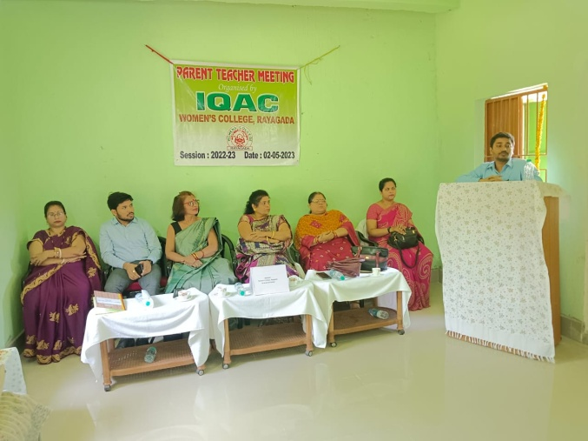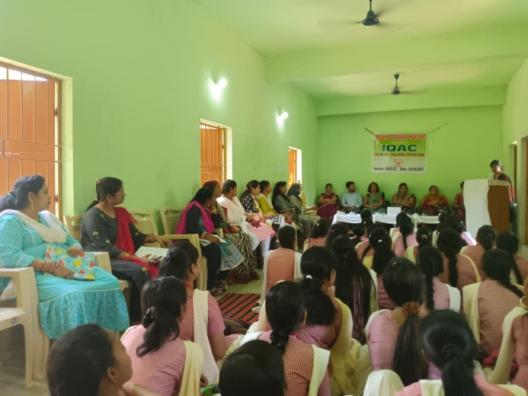
Interaction of the teachers with the Parents

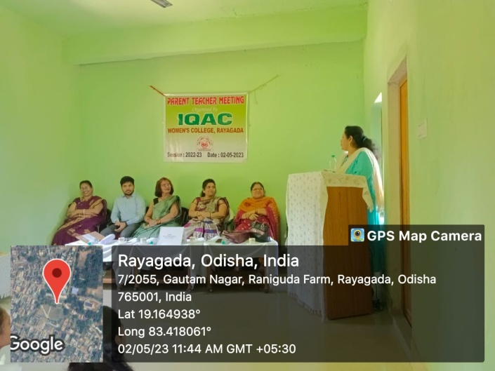
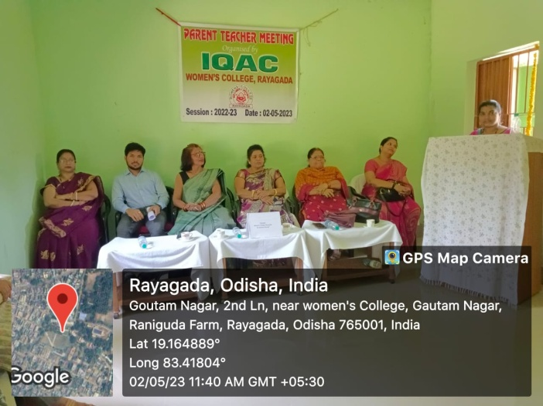
Feedback by the Parents

